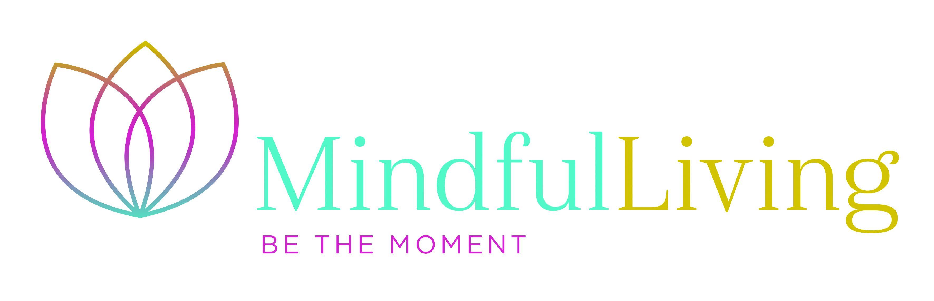

Yoga Nidra Application Form

Name: Occupation:

Date of birth:

Address:

Your phone numbers: Your email:

Your GP: name and phone no;

Name and phone no of someone to contact in case of emergency:

Please specify which 8 week course you wish to book date/location:

Please answer the following questions as fully as possible. The information you give is strictly confidential and will be seen only Sonia or her supervisor

- What has drawn you to apply for a Yoga Nidra course?

- Do you have any physical illness or other limitation that may make sitting, standing, walking, or doing simple stretching difficult?

- Have you at any time experienced periods of clinical anxiety or depression? If so, please tell us about it here. Please include when the last episode was and your main symptoms:

- If you are taking any medication at present, please say what it is, what it is for and any side effects you may have from it:

- Have you had any life event in the last year that might make the work on the course difficult for you (e.g. moving house, separation, work changes, bereavement)?

- Is there anything else going on in your life right now that you would like us to be aware of?

- Are you able to attend all eight sessions of the course, including the all day?

- Are you able to set aside up to one hour every day for the eight week duration of the course to fully engage in home practice? Please consider and specify when you might do this.

- Have you had any previous experience of meditation practice?

Please return this form to:

Sonia Yeandle, Mindfulness Lead, sonia@mindfullivinguk.co.uk

