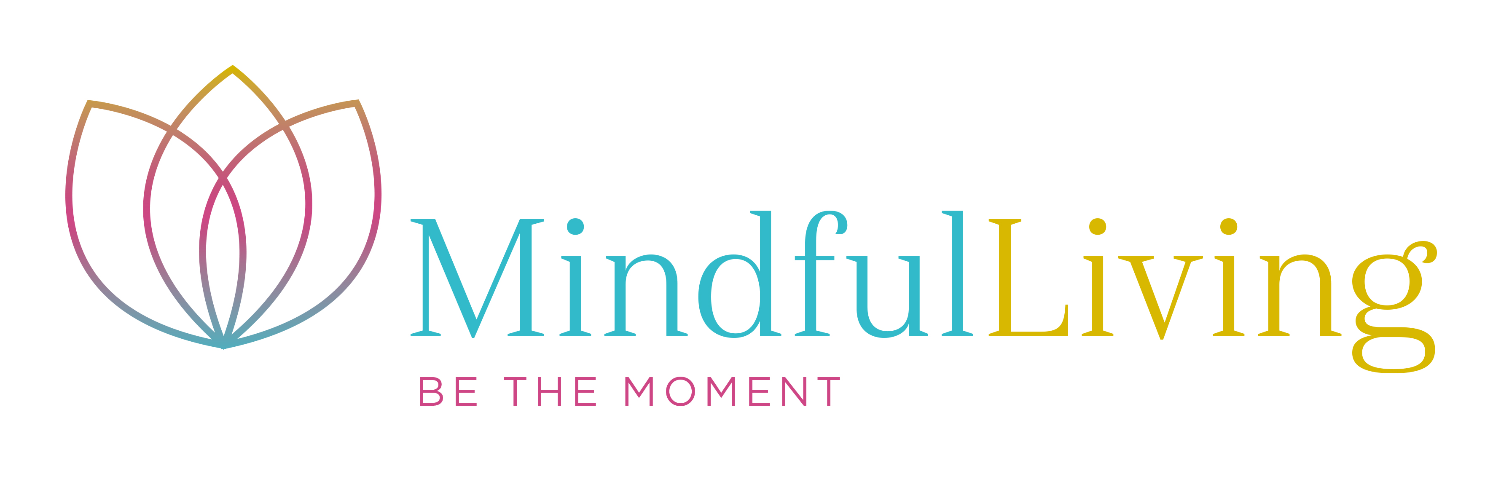
SHORT COURSE BOOKING FORM

This form should be completed and returned, with payment to:
Post – Mindful Living Ltd , 6 First Avenue, Worthing, West Sussex, BN14 9NH
Tele: 07751 435503
Email – sonia@mindfulllivinguk.co.uk

Name of delegate(s): ________________________________________________________________

Organisation: ______________________________________________________________________

Job title/department: ______________________ How long in role: _________________________

Address: Send Invoice to:
_______________________________________ Attention: ____________________________.

_______________________________________ Address: _____________________________

_______________________________________ _____________________________________

Post code: ______________________________

Office tel: ________________________________ Home tel: ______________________________

Mobile: __________________________________ Email: _________________________________

Name of course(s): ________________________ Course start date:

Special dietary requirements: _____________________________________________________________

Authorised signature: _______________________ Print: __________________________________

Position: _______________________________

Please indicate where you heard about this course: ________________________________________

PAYMENT (please indicate your method of payment 1 or 2)

1. Payment enclosed for: £……..……..
(please make cheques payable to Mindful Living Ltd. or complete invoice section below)

2. Please invoice to above address: £………. … ….. Purchase order no: …………….. ………
(company bookings only)

Signature:…………………………………………………..Print Name :……………………………………

Please tick if you would like a receipted invoice:

Please see our cancellation policy

